ARTICLE

Grasshopper DCMD: an undergraduate electrophysiology lab for investigating single-unit responses to behaviourally-relevant stimuli

**Dieu My T. Nguyen1,2, Mark Roper3,4,5, Stanislav Mircic1, Robert M. Olberg6, Gregory J. Gage1,3**

*1Backyard Brains, Ann Arbor, MI 48104; 2Neuroscience & Cognitive Science, University of Arizona, Tucson, AZ 85721; 3Methods of Computational Neuroscience Course, Marine Biological Labs, Woods Hole, MA 02543; 4School of Biological and Chemical Sciences, Queen Mary University of London, London, England; 5Drone Development Lab, Ben Thorns Ltd, Colchester, England; 6Biological Sciences, Union College, Schenectady, NY 12308.*

Observing neural responses to visual stimuli can provide compelling neuroscience laboratories for undergraduates. However, experimental setup can be highly complex and expensive. In this paper, we describe three related hands-on experiments using the grasshopper and affordable technology to bring introductory concepts of neurophysiology to life and enhance student understanding and interest. We simplified a vision-related procedure using open-source and low-cost electrophysiology equipment, the Backyard Brains SpikerBox bioamplifier and an iPad oscilloscope app, to extracellularly record and analyze the descending contralateral movement detector (DCMD) neuron that underlies the grasshopper's motor sensitivity to looming monocular visual cues. In the natural environment, this visual and motor response serves as an escape mechanism for the grasshopper, a prey for a variety of animals including birds and larger insects. With our protocol, students can record and visualize DCMD firing frequencies whilst grasshoppers are exposed to a range of simulated approaching objects on direct collision courses. They will understand the neuroanatomy of a single neuron and the related neural circuitry that contributes to this escape behavior. In addition to the single-unit electrophysiology experiment, we provide two follow-up experiments to encourage further scientific inquiry: finding an ‘ideal’ inter-trial interval to avoid habituation of the DCMD response and investigating whether visibility of the stimulus affects DCMD activity. We also discuss the enthusiastic and constructive feedback received from undergraduates who performed the experiments in a classroom laboratory.

*Key words: descending contralateral motion detector (DCMD); electrophysiology; grasshopper vision; looming; escape response; Backyard Brains (BYB)*

Undergraduate neuroscience programs often face the challenge of incorporating meaningful and engaging hands-on learning experiences into their curricula on limited budgets and resources. Many institutions have developed undergraduate-level teaching labs, including investigations into *Xenopus* tadpole swimming (Li et al. 2014) and invertebrate mechanosensory signaling of a cricket or cockroach leg using electrophysiology (Dagda et al. 2013, Marzullo & Gage 2012, Land et al. 2001). While recording action potentials from the peripheral nervous system of invertebrates demonstrates a number of core neuroscience concepts, the students only experience the concept of sensory input-encoding, and not the complete neural pathway, including the interneurons and output neurons, that produces the neural signals that give rise to an observable animal behavior. Another, possibly more compelling, experiment is to record the responses of neurons that reflects this neural processing and explore the controlled parameters which give rise to the observed responses. The grasshopper “descending contralateral motion detector” (DCMD) system is one way to introduce these concepts.

In this paper, we present a tractable electrophysiology procedure using a low-cost, open-source electrophysiology kit called the SpikerBox (Marzullo & Gage 2012) from Backyard Brains (BYB, backyardbrains.com) that extracellularly records and analyzes the firing rate of the grasshopper DCMD neuron. The DCMD underlies the grasshopper’s motor responses to looming monocular visual cues perceived by their eyes, and provides an excellent systems-level view of a decoding problem being computed by the grasshopper brain in an escape response.

By studying the DCMD system, students also have a chance to learn the role of natural selection on the evolution of the nervous system. The ability to avoid collision with surrounding objects or escape a predator is crucial to the survival of an animal and typically requires the visual detection of approaching stimuli and a motor reaction (Pearson & O’Shea 1984). In the grasshopper visual system (Fig. 1), two pairs of well-studied monocular motion-detecting neurons, the “lobula giant movement detectors” (LGMDs) and the “descending contralateral movement detectors” (DCMDs), underlie the animal’s ability to jump away to escape a potential predator or avoid collision with a looming object. The LGMDs reside in the optic lobe and are excited by approaching visual stimuli. In turn, they send the neural signals to their postsynaptic targets, the DCMDs, which respond to object movements detected by the contralateral (opposite) eye and activate the appropriate motoneurons in the thoracic ganglia to produce the jumping reaction. The LGMDs and DCMDs together make up an early warning system to prepare the escape behavior in the face of possible collision with approaching objects (Rind & Simmons 1992, Hatsopoulos et al. 1995, Gabbiani et al. 1999).

Here we describe the extracellular recording techniques of the DCMD neuron’s response to approaching stimuli in grasshoppers using the SpikerBox (Marzullo & Gage 2012) and an Apple iPad. The SpikerBox provides connections to electrodes for recording electrophysiological responses from an invertebrate preparation, and includes a bioamplifier that connects to a smartphone, tablet, or computer. We also describe our software package, SpikeRecorder, which is currently available for iOS systems and generates visual looming stimuli while simultaneously recording neural activity. We developed analysis methods into the app to perform spike-sorting of the DCMD unit and to analyze the neuronal activity. This software, along with the SpikerBox, are open-source and available on the Backyard Brains website.

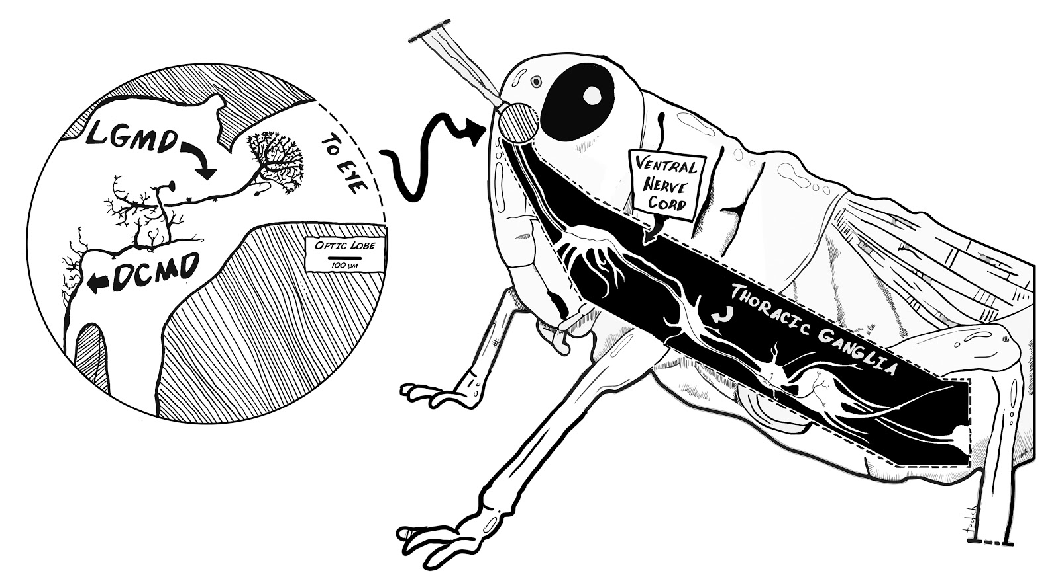

*Figure 1.* Neuroanatomy of the grasshopper’s motion detector neurons. The grasshopper optic lobes (lamina, medulla and lobula) lie in the central brain beneath each of the compound eyes and processes visual information. The lobula giant motion detectors (LGMDs) receive visual signals from the lobula and pass these inputs to the descending contralateral motion detectors (DCMDs). The LGMDs respond to motion of an object seen moving across the insect eye as well as to the looming effect, where an object increases in size as it approaches the eye. The DCMD activates motor neurons in the thoracic ganglia. These primary motion detector neurons underpin the animal’s detector and motor response to a looming object, forming the see-and-jump escape mechanism.

We present three experiments for undergraduate labs: 1) Recording of DCMD signals when the grasshopper is exposed to approaching stimuli, 2) Finding the minimal inter-trial interval, the duration between stimulus presentations to prevent habituation and lack of DCMD responses, and 3) Testing the effect of contrast of the stimulus on DCMD response by adjusting screen brightness. These labs are designed to guide students from an observational question like “why are grasshoppers hard to catch?” to quantifiable questions regarding the visual detection of dangerous objects using electrophysiology. Students can investigate the electrical transmission of highly processed visual information for this life-saving “see-and-jump” escape mechanism.

We also provide results from our experiments to show the efficacy of the tools. We choose our local grasshoppers (Ann Arbor, MI, USA) for ease of obtaining and handling, but many species of grasshoppers can be used, including various species of *Schistocerca* (eg. Burrows & Rowell 1973, Hatsopoulos et al. 1995) and *Locusta* (eg. Rind & Simmons 1992, Gray et al. 2001). In some locations outside the USA, grasshoppers are available for purchase as feeder insects and are inexpensive. Grasshoppers can be found and caught in nearby grass fields by the students, which will also provide context for the experiment as the activity allows for direct observation of the insects’ collision avoidance behavior.

With these simple and affordable techniques, students can observe neural responses to visual stimuli in an invertebrate model, and educators can, in addition to traditional lectures, enhance undergraduates’ understanding of the fundamental concepts of neuroscience.

**MATERIALS AND METHODS**

*Animals & Electrophysiology Preparation*

Depending on location in the world, grasshoppers are available and inexpensive to purchase, or easily found in grass fields in summer. Adult grasshoppers are best, for their relative large size and are therefore easier to handle. However, we have had great success on small grasshoppers as well.  The animals should be refrigerated (suggested temperature: 3ºC) overnight until the experiments.

To prepare for extracellular recording of the DCMD neuron, further anesthetize the grasshopper in ice for 15 min or until the insect is inactive after storage in the fridge. Then, use masking tape to tape the animal ventral (belly) side up onto the corkboard on the SpikerBox apparatus (see Fig. 3), with its head and part of the thorax exposed. Pull back its head using standard sewing thread and tape the thread to the SpikerBox to expose the neck connectives (Fig. 2). If the thread pulling back the grasshopper’s head does not stay in place, heat up a small mixture of beeswax and rosin (a teaspoon total) on a glass petri dish on a heat plate and use a sewing needle or similar to place a dab of the warm liquid on the thread, gluing it to the grasshopper’s neck. This mixture will dry and secure the thread restraint, and is quick and easy to remove from the animal after the experiment.

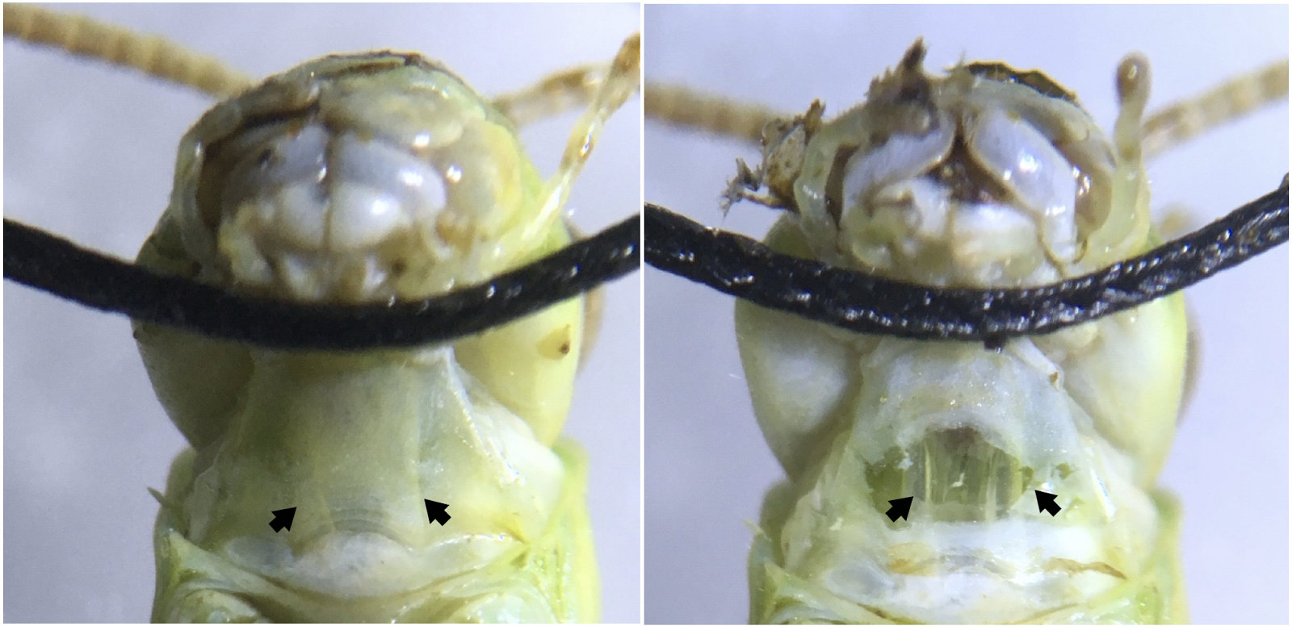

*Figure 2.* Ventral view of the grasshopper neck showing the neck connectives from the head to the thoracic ganglia. (Left) Neck connectives (pointed to by arrows) are visible as white stripes under the neck skin. Sewing thread is used to hold the grasshopper’s head back and in place during the experiments. (Right) A simple neck cut exposes the connectives, two translucent tubes, where the part of the ventral nerve cord can be found. Placing a hook electrode around one connective and exposing the contralateral eye to looming visual stimuli allows DCMD activity to be recorded.

The neck connectives through which the DCMD axons pass can be seen with the naked eye, but a dissecting microscope (suggested magnification: 20X) should be used for more precise visualization and electrode placement. Using a 0.3mm insect pin, make a small incision in the middle of the neck. Modify the straight silver wire recording electrode (0.127mm) into a hook by using tweezers and bending the tip. Then, guide the recording hook electrode with a 3D printed micromanipulator (Backyard Brains, Ann Arbor, MI) into the incision and around the neck connective contralateral to the eye that will be exposed to the visual stimuli (Fig. 3). When the electrode is in place, put a small dab of Vaseline on the incision to keep it from drying out. A 1ml syringe with a small broken needle makes applying Vaseline around the recording site easier.  Ground the reference electrode (sewing needle, 0.6mm diameter) in the grasshopper’s thorax. To check for proper electrode position, record DCMD responses (listen for popcorn-like pops on the speaker connected to the SpikerBox) when the grasshopper is exposed to an approaching plastic stick.

|  |  |
| --- | --- |
| **Table 1. Materials** | |
| **Animal Preparation** | Ice  Microscope (suggested: 20X or higher)  Vaseline  Sewing thread (or similar)  Masking tape (or other types)  Insect pin (0.3mm)  Micromanipulator (BYB)  Spirit level with horizontal tube  Standard ruler  **Included with BYB Micromanipulator:**  Recording electrode  (silver wire, 0.127mm,  modify into hook with tweezers)  Reference electrode  (sewing needle, 0.6mm diameter)  **Optional:**  Beeswax  Rosin  Magnetic stirrer |
| **Spike Recording & Analysis** | iPad (Apple)  Neuron SpikerBox (BYB)  Green smartphone cable  (BYB, SpikerBox to tablet)  SpikeRecorder application  (BYB, currently available for iOS)  Speaker  (suggested: RadioShack mini amplifier)  Blue audio cable  (from SpikerBox to speaker) |

Finally, for the experiment to begin, the longitudinal axis of the grasshopper’s body should be oriented parallel to an Apple iPad 10cm away such that the angle between the eye and the center of the screen is as minimal as possible. A spirit level can be used to easily minimize the angle by lining the level edges to the center of the iPad and the grasshopper’s eye and adjusting until the bubble in the horizontal tube is centered. To achieve the upright position of the iPad, a possible method is to simply tape it against a wall. If possible, recordings should be done in the dark for maximal surrounding darkness, and therefore better contrast intensity of the experimental stimuli. Placing the apparatus inside a cardboard box can easily achieve this. This setup (Fig. 3) is the initial step for all three experiments described below.

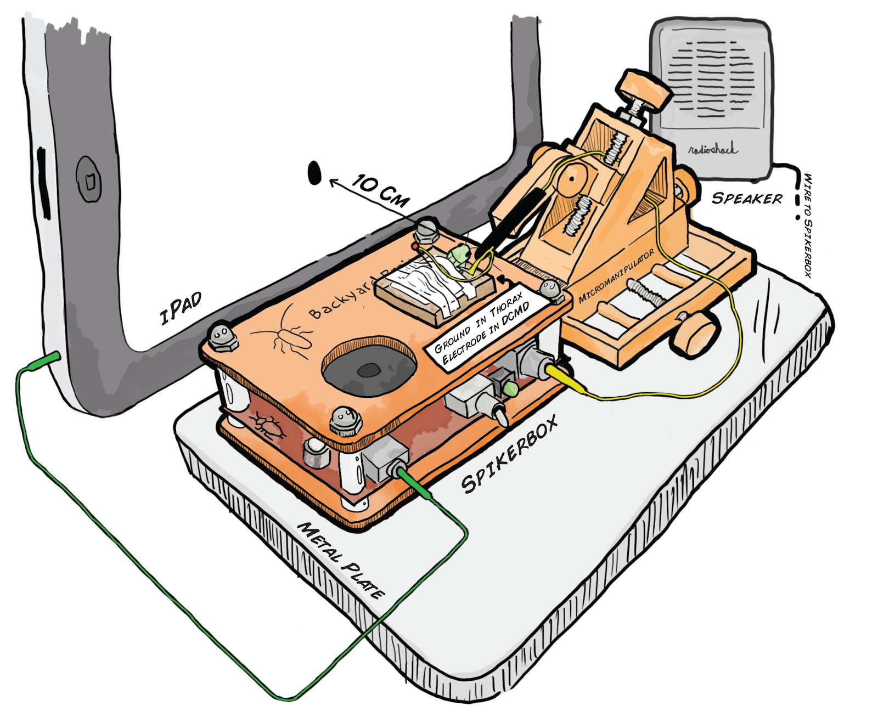

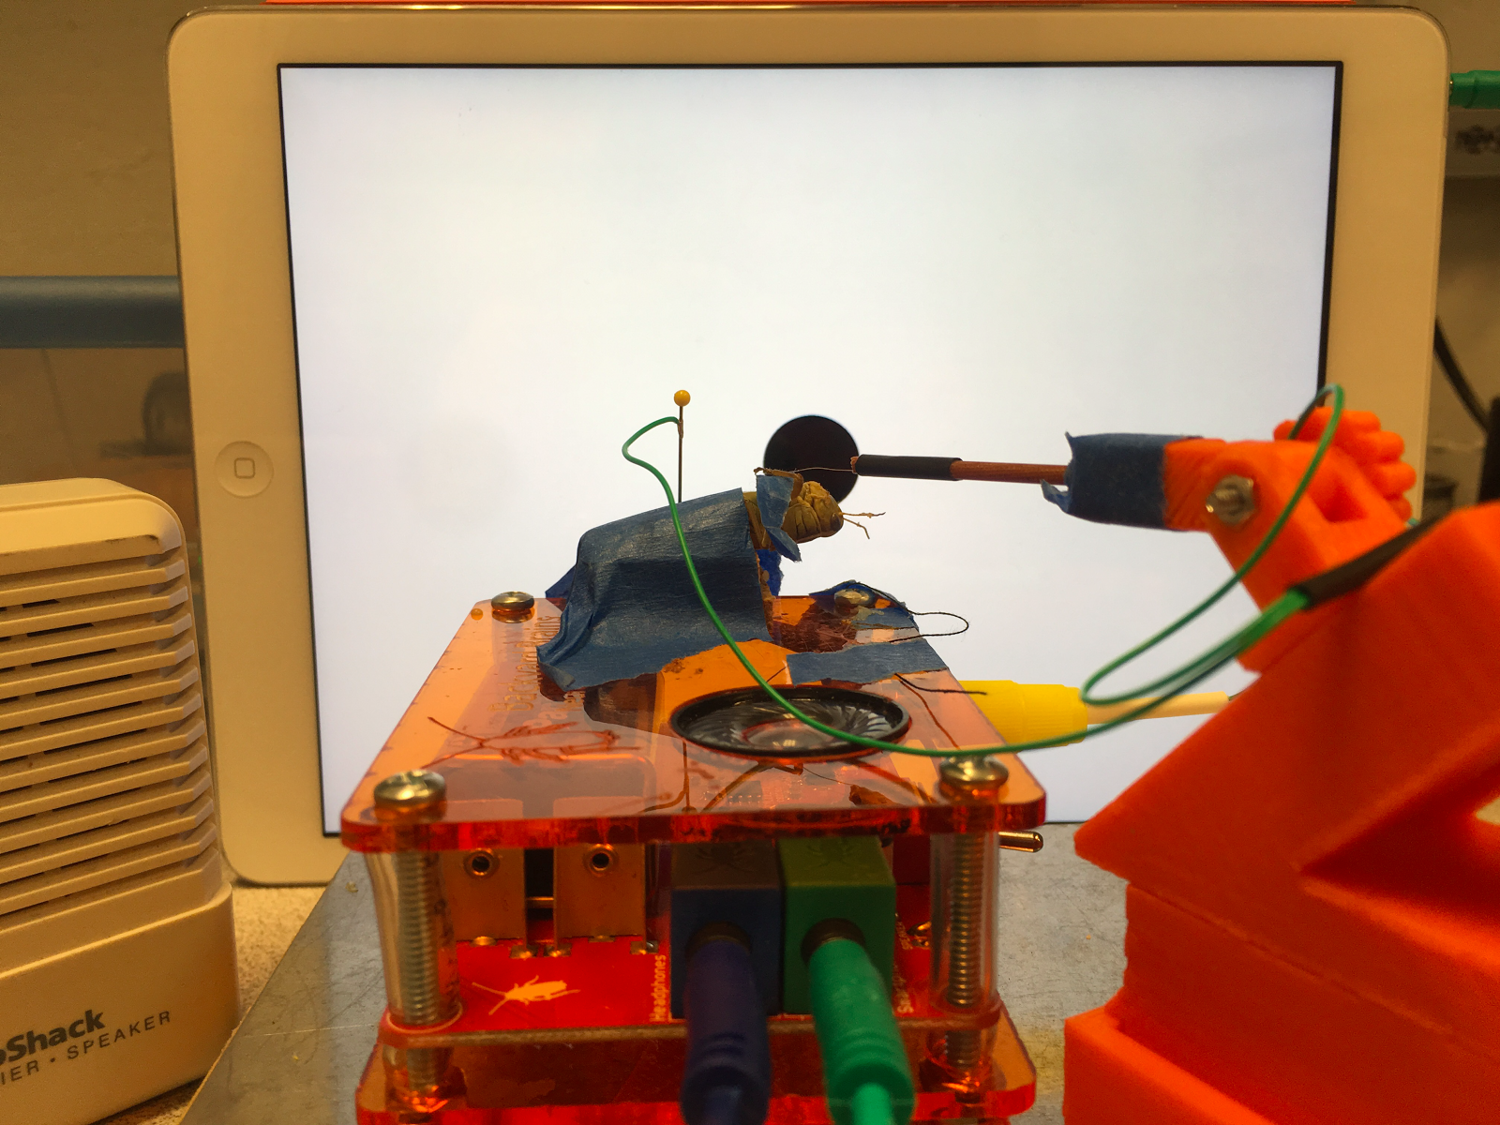 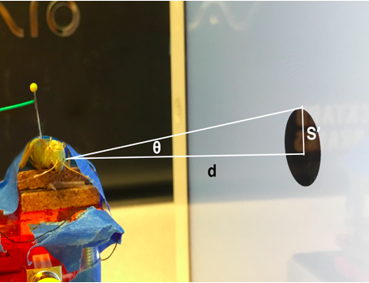

*Figure 3.* Experimental setup to measure descending contralateral movement detector (DCMD) activity during simulated stimulus presentation. (Top) Schematic representation of the experimental setup, grasshopper is taped down onto the corkboard on top of the SpikerBox. The reference electrode is grounded at the thorax and the recording hook electrode, guided by the 3D printed micromanipulator for precision, is placed around the neck connective where the ventral nerve cord and DCMD neuron’s axon is found. The iPad presenting the visual stimuli is placed 10cm from the grasshopper’s eye and the angle between the grasshopper’s eye and the center of the iPad is minimized. (Bottom left) Photograph of the apparatus. (Bottom right) Visual stimuli are displayed on the iPad to simulate the looming effect of an object approaching the grasshopper. The radius S’, subtending angle θ, of a filled black dot can be manipulated to simulate a fixed sized object (S) approaching at a particular constant velocity (v) on the retina of the insect. DCMD recordings can be made during visual simulations of different sized objects moving at different velocities.

*Visual Stimuli & Spike Recording, and Sorting*

Electrophysiological measurements are carried out using the low-cost and open-source bioamplifier, the Neuron SpikerBox (Backyard Brains, v.1.3c). The SpikerBox has a 4x gain instrumentation amplifier, 220x gain amplifier bandpass-filtered 340-1300Hz, and a 20x gain audio amplifier (Marzullo & Gage 2012). It also contains an output port for a Radioshack mini speaker (blue port and cable) and an output port for laptops, tablets, and smartphones (green port and cable) to make neural activity audible, visual, and recordable. During all experiments, the blue and green cables from the SpikerBox should be connected to the speaker and iPad respectively.

The BYB SpikeRecorder iPad application provides both the monocular visual stimuli and recording of DCMD activity. Visual stimuli consist of expanding dark dots (of various radii, S, and velocities, v) on a white background to simulate an approaching and colliding object on a direct collision course. Adjustable parameters in the application include: number of trials, distance between subject and stimulus/screen (cm), object size (cm) and velocity (m/s), inter-trial interval or ITI (s). The ITI is the amount of time between the end of the previous visual display and the commencement of the next looming trial. The iPad displays a blank white screen during this interval. Stimuli of particular parameters S and v are pseudo-randomly presented by the application such that each parameter is repeated an equal number of times during a single experimental session.

Spikes can be sorted from noise after recording in the iPad application (Fig. 4). Noise is identified as false spikes with constant and consistent amplitudes (mV) over time. These spikes have noticeably lower amplitude than the real DCMD spikes. The app allows the student to set minimum and maximum threshold values (mV), and spikes within the range are counted as spikes for further analysis. After sorting the spikes from one recording for one trial (one S, one v), the app automatically performs global sorting for the rest of the trials conducted during one experimental session using these threshold parameters.

*Experiment 1: Looming Stimuli DCMD Experiments*

**Objective**: This experiment, coupled with instructors’ lectures and introduction to neuroanatomy of the grasshopper visual-motor system, demonstrate to students the basic electrical properties of the brain and how sensory input stimulates a particular neuronal system to drive a certain animal behavior, using a simplified version of electrophysiology and model invertebrate. Students can follow the procedure below, with modifications appropriate for a classroom lab or other learning settings, after developing their own hypotheses, such as when the DCMD neuron would peak in firing frequency when the object approaches the grasshopper’s eye, or how different object sizes and velocities may affect DCMD response.

**Procedure**: In the SpikeRecorder application, keep the following parameters constant: 10cm distance between the grasshopper’s eye and the iPad and inter-trial intervals, ITI, of 45s to reduce habituation of the DCMD response to visual stimuli. Enter required values of choice for S (object radius) and v (object approaching velocity), to begin, we suggest choosing S of 6cm and a range of v values (-2, -4, -6, -8m/s). Each combination of S and v should be repeated for 3 simulation trials. Such parameters will create an experiment, approximately 10 minutes in duration, that allows students to observe the differences in DCMD response to objects of the same size but approaching at different velocities. Once the application is set up, check again for the correct iPad positioning and connected cables as described above and press ‘Start’ in the iPad app to begin. Observe the approach of the black dots and listen for DCMD spikes in form of popcorn popping sounds through the speakers.

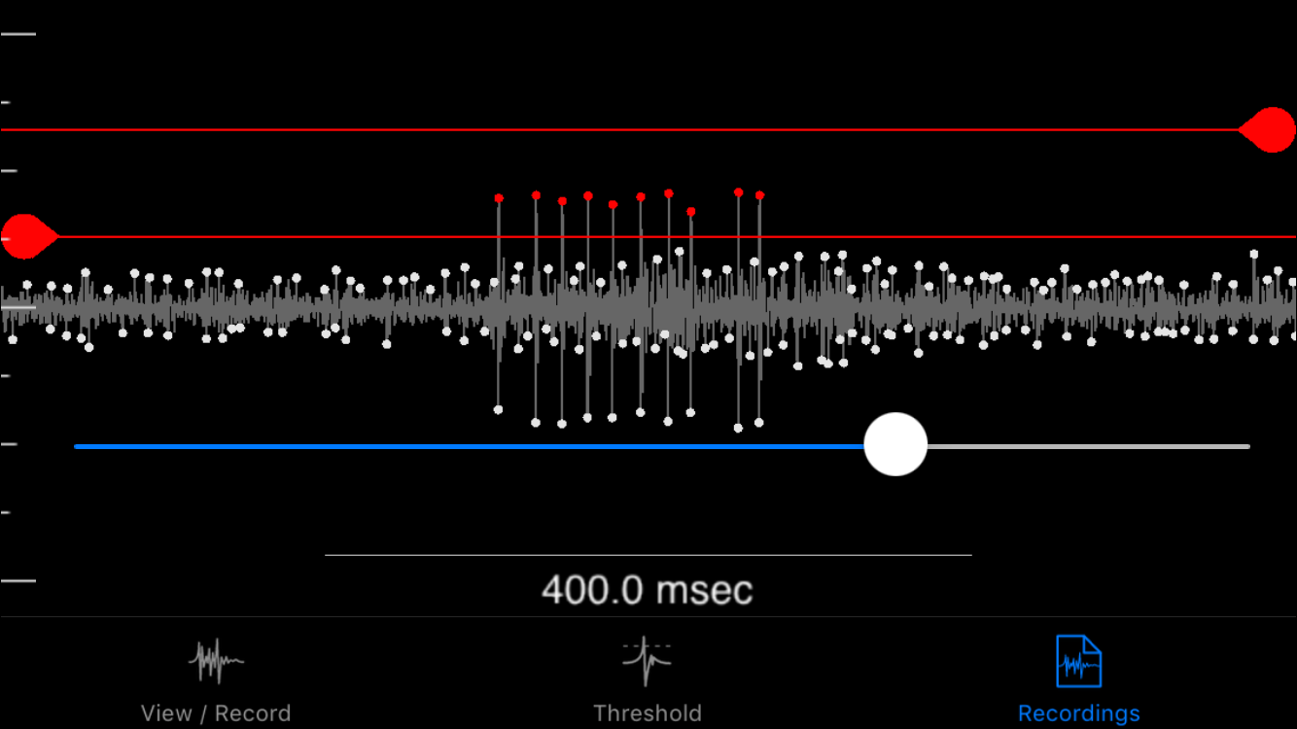

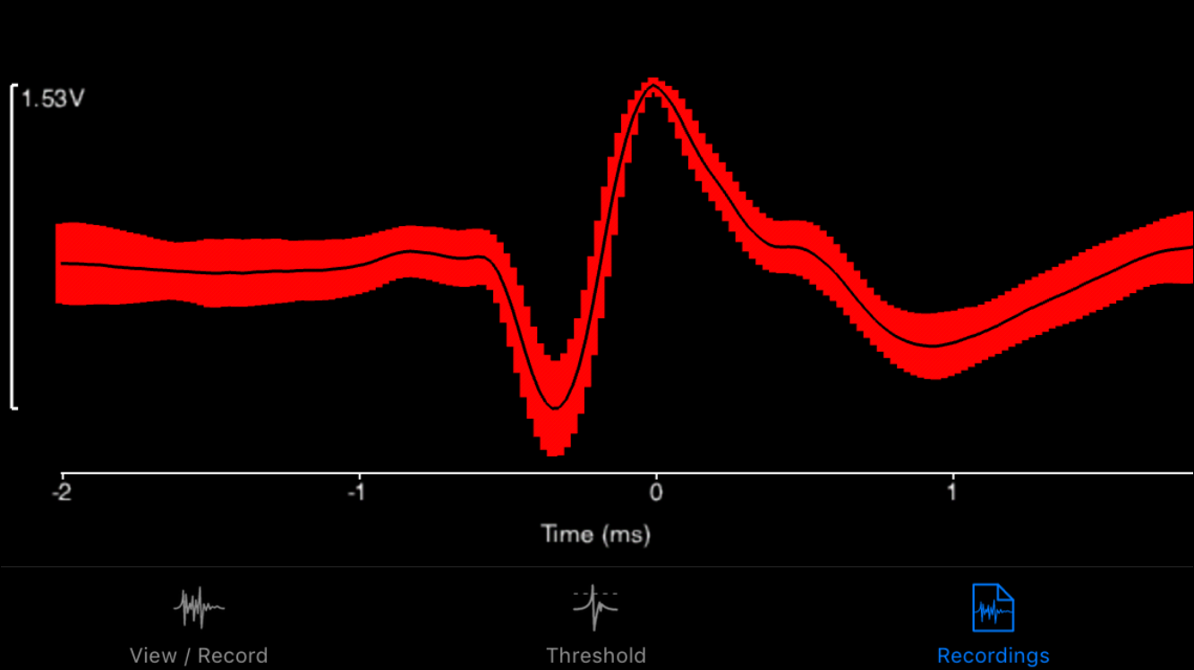

*Figure 4.* Spike sorting in the SpikeRecorder iPad app. SpikeRecorder provides both the looming visual stimuli and recording and analysis of DCMD activity. DCMD spikes can be sorted from noise after recording by providing minimum and maximum spike threshold values. These values can be applied to all recordings made within a single grasshopper’s experimental session. (Top) The app’s output of the DCMD recordings during a looming experiment (object size S = 6cm, velocity v = -2m/s) with a minimum spike amplitude of approximately 0.30mV, maximum of 0.65mV. Red dots are spikes recorded within the thresholds. (Bottom) The app can also analyze data after spike sorting. Shown here is an example graph showing the average waveform of DCMD activity over time, within 1 standard deviation.

*Experiment 2: Inter-trial Interval Experiments*

**Objective**: In this experiment, students will be exposed to the concept of inter-trial intervals (ITIs), often used in behavior studies, such as the literature DCMD experiments (Rind & Simmons 1992, Hatsopoulos et al 1995). ITIs, the time between trials, ensure that each trial’s stimulus is distinct and thus the animal would not develop habituation to the presented stimuli, preventing accurate DCMD responses. Instructors can discuss the use of ITIs of at least 40s long used in literature papers (e.g. Rind & Simmons 1992). Students can hypothesize the effect of different ITIs on DCMD activity and subsequently implement this experiment to investigate their predictions, and determine a sufficiently long interval to avoid habituation to the stimuli.

**Procedure**: With the same setup as Experiment 1, enter parameters to be kept constant in the application: 10cm distance between eye and iPad, chosen number of trials per ITI, and one pair of S and v values. We recommend using three ITIs to produce distinctly different DCMD responses: 45s, 22.5s, and 1s.

*Experiment 3: Screen Brightness Experiments*

**Objective:** This experiment aims to engage students in further experimental inquiry after they have performed the previous two activities. Here, they can hypothesize and test the effect of screen brightness, which affects the contrast intensity and thus visibility of the black stimuli against the white background, on DCMD response.

**Procedure:** Adjust brightness of the screen in the Settings of the iPad, whose brightness is approximately 425 cd/m2 at maximum and 5 cd/m2 at minimum. Constant parameters include 10cm distance between eye and iPad, 45s ITI, number of trials per brightness level, and one pair of S and v values. Students may choose different brightness levels, each is a separate experiment. We recommend initially observing the effects of the maximum and minimum screen brightness levels (the iPad screen will not be completely black at the minimum setting, but very dim).

*Data Analysis*

The SpikeRecorder app includes data analysis and visualization functionality. DCMD activity and change in angular size of the visual stimulus over time can be visualized in perievent time histograms or PETHs (see Bretschneider and De Weille 2006 for a review of PETHs, also known as peri-stimulus time histograms or PSTHs) and raster plots, with time to collision defined as the 0 second point. Students may save the data graphs from the app and engage with the biostatistics as a post-lab assignment.

For more in-depth analysis, data, recorded and contained within the SpikeRecorder application can be exported to JSON files, which can then be imported into MatLab (MathWorks, Inc.) using the open-source JSONlab toolbox. The MatLab code files are available for download from the Backyard Brains GitHub repository (see Supplementary Information). A database of the experimental data (recording and spike timestamps, stimulus angles, time of collision) will be created by the code. Perievent time histograms and raster plots can then be plotted to visualize firing rate and timing of spikes in relation to stimulus.

*Student Laboratory & Evaluation*

During the Fall 2016 semester, students in the MCB81 course taught by David Cox at Harvard University participated in a 2hr classroom laboratory performing the first experiment, as described above. Students were sent an online survey a week after the lab to rate the effectiveness of the various aspects of the experiment, such as the ease of the grasshopper preparation and whether the lab section improved the students’ understanding of the use of electrophysiology to study brains and behavior. The answers were on the scale of ‘1=Strongly agree’ to ‘5=Strongly disagree.’ The overall rating at the end of the survey asked students to rate the whole lab as ‘1=Terrible’ to ‘10=Excellent.’ The last question asked students for ideas for improvements.

## RESULTS

*Technical considerations*

To confirm that the SpikeRecorder accurately records the simulated time of collision, we performed tests to check for the synchronization between the recorded and simulated time of collision (0s on the perievent and raster plots, Fig. 5).

First, the refresh rate of the iPad screen was measured. A 5mm phototransistor (EverLight, PT334-6C model) was placed 10cm from the screen, to ensure that it would get light from the whole screen, and a single trial of the approaching stimulus (S: 6cm, v: -2m/s, at maximum screen brightness) was run. The recording output of the phototransistor was observed on an oscilloscope (Tektronix, TDS2000 model). The duration of one frame was 16.8ms, corresponding to 60Hz refresh rate (60 frames per sec) of the iPad screen. Trials with stimuli of various speeds were completed. We then calculated the delay between the recorded time of collision on the software and the actual time when the stimulus filled up the whole iPad screen for each S and v parameter (see above). A delay of up to 60ms for the fastest stimuli (e.g. velocities of -6 and -8m/s) was recorded. This result does not have a significant effect on DCMD response recordings, as data visualized in Fig. 5 to 7 show results in accordance with literature findings. But this delay issue is still taken into account when determining the accuracy of future experimental results and for future improvements to the app.

*Animals*

We performed the three experiments above-described to verify the efficacy of our equipment and to refine the protocol, as well as provide results as points of reference. In our experiments, due to dependence on local availability and catching abilities, both adult and nymph, male and female, grasshoppers (*Melanoplus femurrubrum* and *Melanoplus differentialis*) were caught in Nichols Arboretum, MI, USA, in June and July 2016. The animals were refrigerated (average temperature 3ºC) until the experiments (average 4 days).

*Experiment 1: DCMD response to approaching stimuli*

In this replication of literature DCMD studies by Rind & Simmons (1992) and Hatsopoulos et al. (1995), 22 grasshoppers were tested across 57 recording sessions.  An average of 2.62 sessions was conducted on each subject (range = 1 to 5 sessions). Each grasshopper was individually exposed to visual stimuli on the iPad while the SpikeRecorder application recorded DCMD activity amplified by the SpikerBox. Stimuli virtually approached the grasshopper’s eye on a direct collision course. Session parameters kept constant across all DCMD experiments were: 10cm distance between the grasshopper’s eye and the iPad; 16 trials per pair of S and v; and inter-trial intervals, ITI, of 45s to reduce habituation of the DCMD response to visual stimuli. Each stimulus is a pair of S (6 and 8cm) and v (-2, -4, -6, -8m/s). Initially, two separate sessions of stimuli with constant S and varying v were performed on the same grasshopper. However, to prevent the effect of habituation of the DCMD to the stimuli presented later in a second session, the SpikeRecorder application was modified to pseudo-randomly present stimuli of varying S and v throughout a continuous session of approximately 2 hours, 128 trials. Because we were not limited to a classroom timescale, we allowed the experiments to run longer than the amount of trials suggested in Methods to obtain more data for analysis. Students may set up a similar, longer experimental session if desired.

Here, we show results of data analysis in both the SpikeRecorder app (Fig. 5) and MatLab (Fig. 6).  Students may simply use the data analyses function of the app, or use the MatLab code to gain experience in data analysis and visualization. The SpikeRecorder app (Fig. 5) generates analysis of an extracellular recording of DCMD response for dots 6cm and 8cm in radius approaching at four velocities (-2, -4, -6, -8m/s) in a perievent time histogram (PETH) and raster plot. The MatLab code we developed allows data analyses similar to the SpikeRecorder app, with a wider range of tools. As shown in Fig. 6, compared to the overall graph from the app (Fig. 5), DCMD activity patterns of a dot of the same size (S: 6cm) approaching at various velocities (v: -2, -4, -6m/s) can be better visualized in various figure types. Both the SpikeRecorder app and MatLab analyses provide the following information about the grasshopper DCMD and its role in the insect’s escape mechanism: As shown in Fig. 5 and 6B, DCMD firing rate was silent for more than 1s after the onset of the stimulus, then increased approximately 0.2s before the time of collision (0s on all graphs) and peaked around the collision between the object and the eye, when the object's image on the grasshopper's retina reached a certain angular size (Fig. 6A & 6B). As shown in both Fig. 5 and 6A & 6B, with the dots at the slowest velocity (-2m/s), peak firing occurred approximately before the time to collision between the eye and the stimuli. With increasingly faster velocities (-4, -6, -8m/s), DCMD firing peaked up to approximately 0.05s after collision, with possible technical delay above-discussed. The greater the velocity of the stimulus, the later the DCMD peak firing occurred, and the lower the firing frequency, as shown in Fig. 6A and 6B comparing stimuli of a fixed S (6cm) approaching at -2, -4, -6m/s. In Fig. 6C, we show a false-color representation graph of DCMD peri-collision firing rate of all 57 sessions from 22 grasshoppers. As seen, 50 of the 57 sessions (87.7%) had a clear peak in firing within +/- 0.1s of collision.

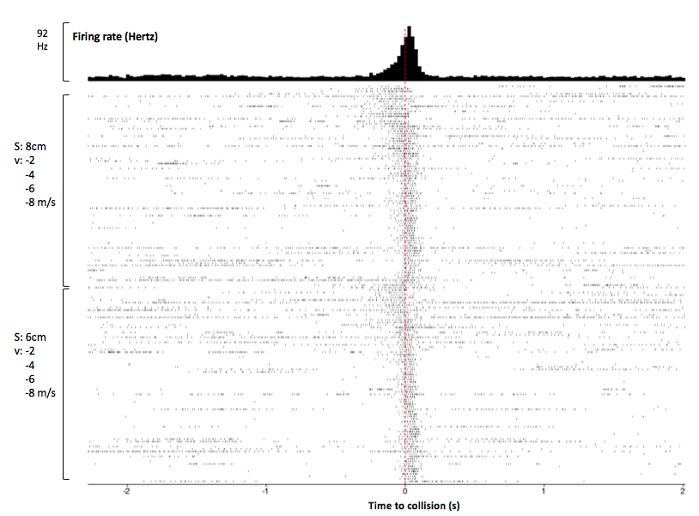

*Figure 5.* Mobile app analysis of DCMD response to approaching objects, with additional annotations After spike sorting, the SpikeRecorder app produces a perievent time histogram (PETH) and raster plot to show DCMD firing activity 2s before and after collision.  Peak firing was 92Hz around collision. Rasters are ordered top to bottom by large to small S, then slow to fast v. Similar patterns of DCMD activity are seen for dots 6cm and 8cm in size, with peak firing frequency before collision when the dots are approaching at slower velocities (-2 and -4m/s) compared to those at faster velocities (-6 and -8m/s).  Session: G17-071416-01 (see Supplementary Information). Parameters:d: 10cm; S: 6, 8cm; v: -2, -4, -6, -8m/s; trials per pair of S and v: 30; ITI: 45s. Collision at 0s.

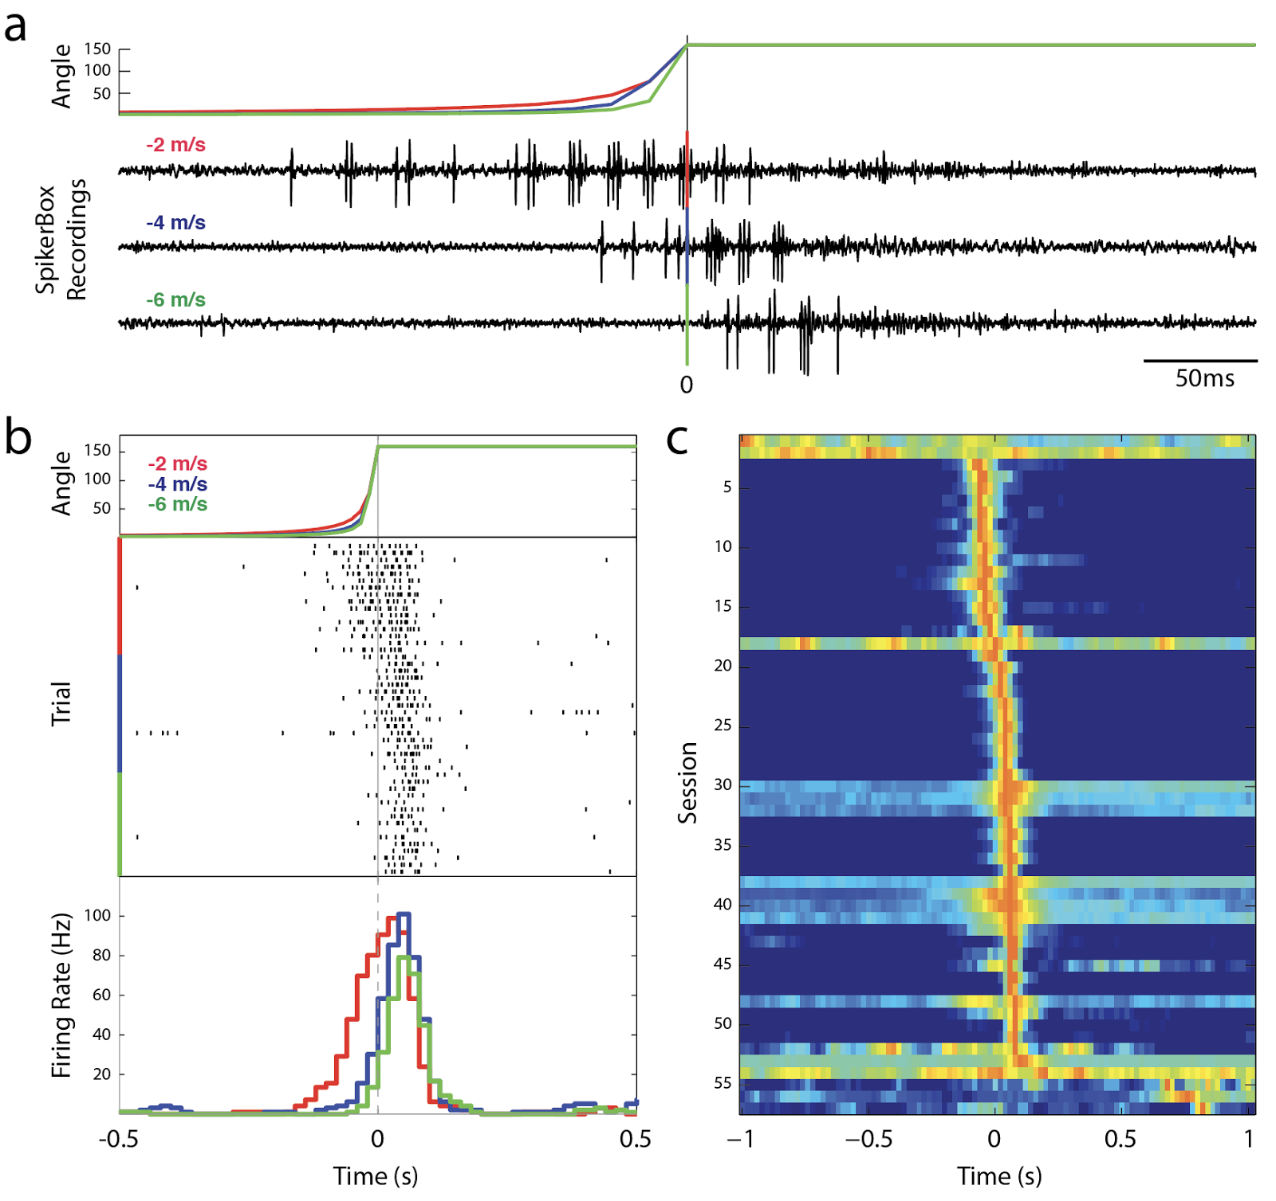

*Figure 6.* Analysis of DCMD response to approaching objects in MatLab. Importing data from the SpikeRecorder app into MatLab allows further data analysis and visualizations.  **(a)** Comparison of DCMD activity in SpikerBox traces from iPad across 3 values of v: -2, -4, -6m/s for a fixed S: 6cm. DCMD firing rate increases and peaks as the angle of the object subtended on the grasshopper eye reaches maximum. 0s indicates computed collision with grasshopper.  Session: G17-071416-01 (see Supplementary Information). Parameters:d: 10cm; trials per S/v pair: 30; ITI: 45s. Collision at 0s. Timescale: 0.5s **(b)** Spike rasters (center) show DCMD spiking activity (tick marks) across trials within a session and are sorted by velocity. Note delay in DCMD onset and decrease in spike timing variance as velocity increases. Session: G15-071316-01(see Supplementary Information). Parameters:d: 10cm; trials per S/v pair: 30; ITI: 45s. Collision at 0s. Timescale: 1s **(c)** Session analysis of DCMD responses.  Each row shows a false-color representation of DCMD peri-collision firing rate each of the total 57 sessions in our database (bin size = 0.2s).  Red indicates peak firing rate. Sessions are sorted by time of peak firing rate.  50 of the 57 sessions (87.7%) had a peak in firing within +/- 0.1 s of collision. Timescale: 2s.

From a neuroethological perspective, instructors can discuss these results as explaining how the form of the DCMD neuron contributes to its function in the grasshopper’s escape behavior. The more rapid the approaching object (seen in our stimuli at v of -6 and -8m/s), the fewer and later the DCMD spikes. Does this imply a lower chance of successful avoidance of collision, or does a higher firing rate of slower objects inform the grasshopper it has more time to make a final decision?

*Experiment 2: DCMD activity during various inter-trial intervals (ITIs)*

ITI experiments were carried out with 2 grasshoppers. The setup was the same as Experiment 1. Constant parameters included 10cm distance between eye and iPad, 30 trials per ITI, and one pair of S (6cm) and v (-2m/s). Three ITIs were chosen: 45s, 22.5s, and 1s and the total experiment consisted of 90 trials.

An ITI of 1s yields low and late firing frequency (approximately 20Hz), compared to the frequencies with ITIs of 22.5s (45Hz) and 45s (75Hz), shown in Fig. 7. The 45s ITI showed the most consistent and frequent firing, and is the suggested minimum for the other experiments.

*Experiment 3: Effect of screen brightness on DCMD response to approaching stimuli*

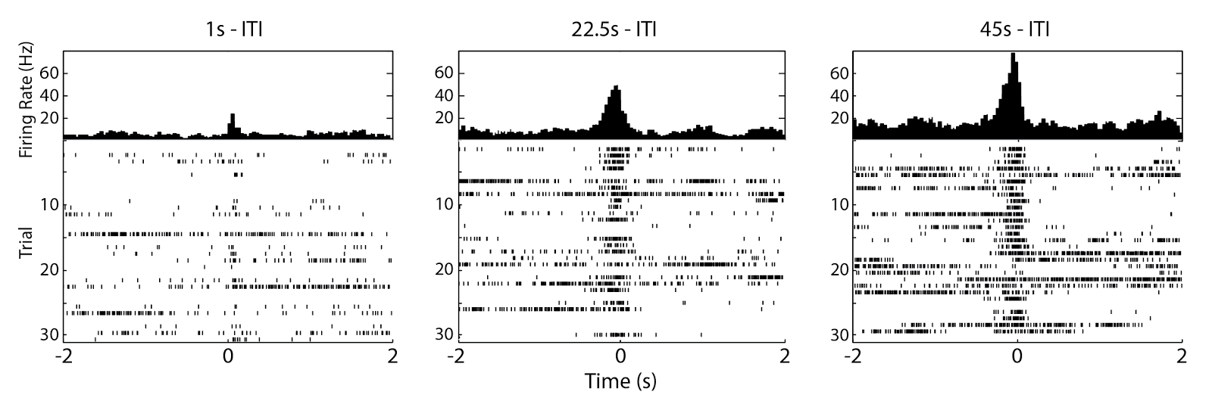 *Figure 7.* Varying the inter-trial interval reveals DCMD response needs time to recover. Peak firing frequency is around 20, 45, and 75Hz for 1, 22.5, 45s ITI, respectively. The 45s ITI shows the most consistent and frequent firing of the DCMD, and is the ITI of choice for other experiments. Sessions: G25-072416-01 through G25-072416-03 (see Supplementary Information). Parameters:d: 10cm; S: 6cm; v: -2m/s; trials per ITI: 30; ITIs: 45, 22.5, 1s. Collision at 0s.

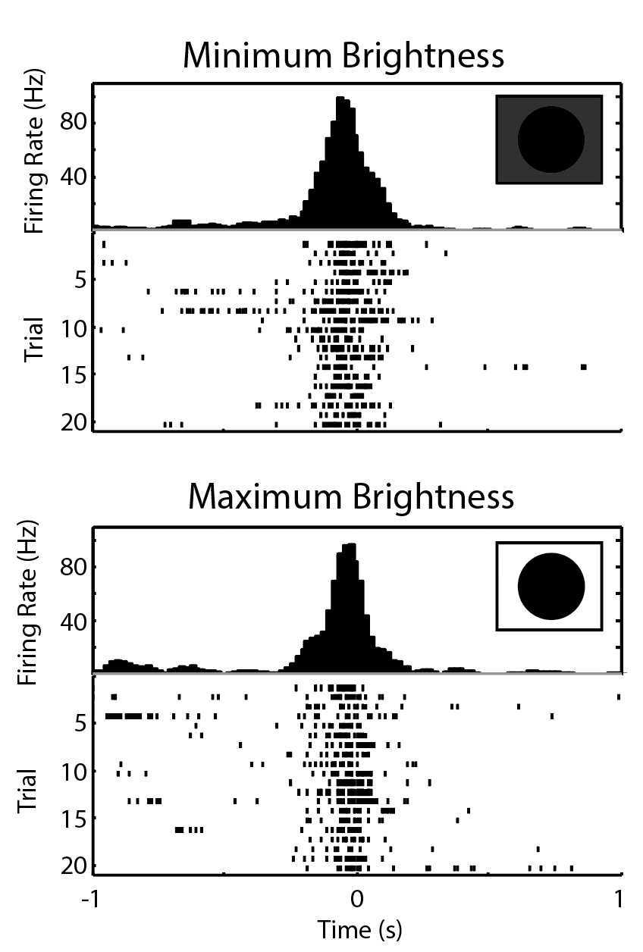

*Figure 8*. DCMD shows little difference in response to varying iPad screen brightness. At minimum brightness (top), DCMD firing rate is consistent and peaks at -0.02s with 96.7Hz. At maximum brightness (bottom), firing rate also peaks at approximately the same rate (99.2Hz) and time (-0.06s). There was not a significant difference detected from spiking activity between the dimmest and brightest screen levels (Paired t-test of number of spikes in trials between -0.1s and 0.1s; P = 0.320). Sessions: G26-072516-02 and G26-072516-03 (see Supplementary Information). Parameters: d: 10cm; S: 6cm; v: -2m/s; trials per brightness level: 20; ITIs: 45s. Collision at 0s.

Maximum and minimum brightness levels were set for two separate experiments. Constant parameters included 10cm distance between eye and iPad, 45s ITI, 20 trials per brightness level for 40 trials total, and one pair of S (6cm) and v (-2m/s). As shown in Fig. 8, the DCMD activity profiles at maximum and minimum iPad screen brightness are not substantially different, with 99.2Hz and 96.7Hz peak frequency, respectively. This results suggest that light level does not affect how visual stimuli evoke DCMD responses. In dim background lighting, the grasshopper’s eyes can still detect the edges of the expanding dots and react to avoid the looming collision– an advantageous escape behavior in natural settings.

*Student Evaluation*

Students generally enjoyed the Looming Stimuli DCMD experiment and responded positively. Post-lab survey data were collected from 18 undergraduates. For the technical aspects of the experiment, 72% ‘strongly agreed’ or ‘agreed’ that the grasshopper preparation mounting using tape and thread was easy to learn and user friendly (Fig. 9). 50% or more students ‘strongly agreed’ or ‘agreed’ that the visual stimulus worked reliably, that they were able to clearly hear a neural response to the looming stimuli displayed on the SpikerBox, and that they were able to sort spikes from the recordings and display graphs on a mobile device to show relative timing of spikes to the virtual moment of collision. The most challenging part of the protocol might be electrode placement, which 44% of the students thought was easy.

As for the evaluation of the lab’s effect on student understanding and interest in neurophysiology, at least 60% of the students ‘strongly agreed’ or ‘agreed’ that the lab increased their interest in studying the neural basis of animal behavior, that they are able to understand how electrophysiology can be used to study brains and behavior, that they understood how the DCMD works as an escape

response, that the lab encouraged them to generate and test their own hypotheses and increased their interest in becoming a neuroscientist.

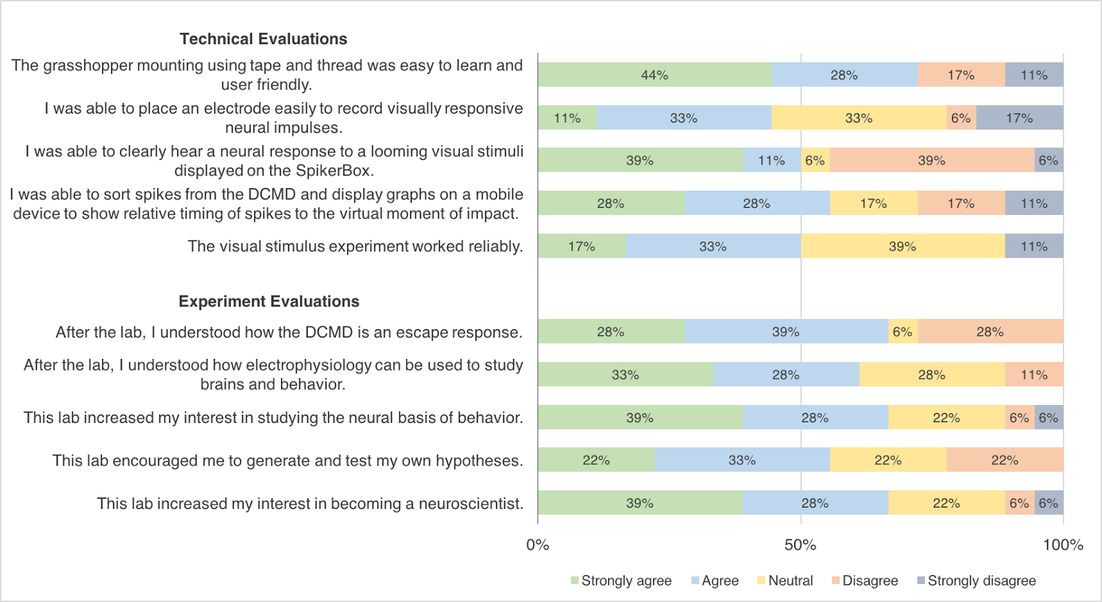

*Figure 9*. Student evaluation of the Looming Stimuli DCMD Experiment. Survey data from 18 undergraduates in the MCB 81: Fundamentals of Neuroscience course taught by David Cox at Harvard University. Most students were able to perform the protocol, including grasshopper preparation and data analysis on a tablet or mobile device, with electrode placement possibly being the most difficult step. The lab enhanced student understanding and interest in electrophysiology as a tool and in neuroscience overall.

Overall, 16 out of the 18 students rated the lab 7 or higher out of 10, with 10 being ‘Excellent.’ Ideas for improvements include providing a clearer diagram for electrode placement in the grasshopper’s neck and improving the user interface of the SpikeRecorder app by framing the data analysis steps as a sequence (e.g. spike sorting before graph viewing). These suggestions have been addressed in this paper.

**DISCUSSION**

The three experiments presented in this paper aim to provide classroom laboratories to introduce undergraduates to the concepts of neurophysiology using a manageable grasshopper model and a simplified essential tool of neuroscience: electrophysiology. Our results demonstrate the efficacy of the tools, as the SpikerBox and SpikeRecorder app successfully reproduced grasshopper DCMD responses seen in the current literature (Rind & Simmons 1992, Hatsopoulos et al. 1995). Close to Hatsopoulos et al.’s 1995 and Rind & Simmons’ 1992 results, which show silence in DCMD activity during the first 2s of a 2.75s approach, our results find that the DCMD begins to fire rapidly approximately 1.8s after the stimulus begins the simulated collision course with the grasshopper’s

eye. The exact timing of increased DCMD activity depends on stimulus size and velocity, but a general trend is established: silence in DCMD activity immediately after the stimulus onset and a rapid increase to peak firing frequency around the time of collision between the stimulus and the animal. Our results also show that with stimuli of faster velocities, DCMD firing frequency is relatively lower, as Rind and Simmons found in their 1992 paper. Additionally, cited literature studies (Rind & Simmons 1992, Hatsopoulos et al. 1995, Gabbiani et al. 1999, Rowell 1971b) use ITIs of at least 40s and our experiments have demonstrated the importance of using an ITI sufficiently long (at least 40s) to consistently obtain DCMD signals. Thus, the affordable and simple experiments discussed in this paper could be implemented in undergraduate laboratories to provide students with hands-on activities to better understand the neurophysiology concepts of neuroanatomy, sensory responses, and the electrical properties of the brain.

**Effectiveness of the experiments**

Overall, the students who performed the Looming Stimuli DCMD experiment at Harvard University during the Fall of 2016 provided enthusiastic feedback and evaluated the hands-on activity as contributing to their understanding of electrophysiology as a tool to investigate the neural basis of a particular animal behavior, as well as to their general interest in neuroscience as a potential academic pursuit. The students also made valuable suggestions for improvements, such as using distant relatives of the grasshoppers for more variations, and providing clearer protocol to reduce the difficulty of placing the recording electrode into the grasshopper’s neck, which we have addressed in this publication and are discussed below.

**Procedure challenges**

Our results serve as points of reference for students to compare their results against, though variations are expected. Possible procedural challenges may arise, especially given the limited time in a classroom lab, and here we discuss several potential problems and solutions. First, noise signals are likely to be present during neural recordings and may obscure the desired signals. Since a noise-free environment is not realistic in a classroom, simple Faraday cages may be used. This provides the instructor with an opportunity to briefly explain how a closed conductive container, like a wire mesh box, can shield the materials inside from outside electromagnetic interference. If desired, this can also be an additional experiment, in which students can observe the differences in noise and neural signals during various levels of interference. Another challenge students may encounter is the animal preparation. If the grasshopper wakes up early from the anesthesia and becomes active during the surgery, it should be replaced into ice until it is inactive once more. Electrode placement, especially the hook recording electrode around the neck connective, is relatively simple but does demand using a microscope and micromanipulator for precision. Adult grasshoppers should be used if possible, as their neck connectives are larger and more visible. If the electrode placement around a neck connective proves too difficult, students may modify the hook electrode into a simple straight wire and place it between the two neck connectives. This is too imprecise for full DCMD analysis, but the amplification would be sufficient for DCMD spikes to be visualized and recorded.

**Further experiments**

We encourage modifications and experiments that may arise from our procedures. Example research ideas using the SpikerBox amplifier and grasshoppers or similar invertebrates include: somatotopy with grasshopper legs, the effect of temperature on neuronal responses or spikes, and the effect of drugs (e.g. nicotine) on the nervous system. Detailed experiments can be found on the Backyard Brains website.

###### REFERENCES

Bretschneider F & De Weille JR (2006). Stimulus-Response Characteristics: The PSTH. In Introduction to Electrophysiological Methods and Instrumentation. Elsevier Ltd.

Burrows M & Rowell C H F (1973) Connections between descending visual interneurons and metathoracic motoneurons in the locust. Journal of Comparative Physiology A 85:221-234.

Card GM (2012) Escape behaviors in insects. Current Opinion in Neurobiology 22: 180-186.

Dagda RK, Thalhauser RM, Dagda R, Marzullo TC, Gage GJ (2013) Using Crickets to Introduce Neurophysiology to Early Undergraduate Students. The Journal of Undergraduate Neuroscience Education, Fall 2013, 12(1): A66-A74.

Gabbiani F, Krapp HG, Laurent G (1999) Computation of object approach by a wide-field, motion-sensitive neuron. Journal of Neuroscience 19(3):1122–1141.

Gray JR, Lee JK, Robertson RM (2001) Activity of descending contralateral movement detector neurons and collision avoidance behaviour in response to head-on visual stimuli in locusts. Journal of Comparative Physiology A 187: 115-219.

Hatsopoulos N, Gabbiani F, Laurent G (1995) Elementary computation of object approach by a wide-field visual neuron. Science 270(5238):1000-1003.

Land BR, Wyttenbach RA, Johnson BR (2001) Tools for physiology labs: an inexpensive high-performance amplifier and electrode for extracellular recording. J Neurosci Methods 106: 47–55.

Li WC, Wagner M, Porter NJ (2014) Behavioral Observation of Xenopus Tadpole Swimming for Neuroscience Labs. The Journal of Undergraduate Neuroscience Education, Spring 2014, 12(2): A107-A113.

Marzullo TC & Gage GJ (2012) The SpikerBox: A Low Cost, Open-Source BioAmplifier for Increasing Public Participation in Neuroscience Inquiry. PLoS ONE 7(3): e30837. doi: 10.1371/journal.pone.0030837.

O’Shea M, Rowell CHF, Williams JLD (1973) The anatomy of a locust visual interneurone; The descending contralateral movement detector. Journal of Experimental Biology 60(1):1-12.

Pearson KG & O’Shea M. (1984) Escape behavior of the locust. In Neural Mechanisms of Startle Behavior pp 163-178. Springer US.

Ramos RL, Esposito AW, O’Malley S, Smith PT, Grisham W (2016) Undergraduate Neuroscience Education in the U.S.: Quantitative Comparisons of Programs and Graduates in the

Broader Context of Undergraduate Life Sciences Education.

Journal of Undergraduate Neuroscience Education, Fall 2016,

15(1): A1-A4.

Rind FC & Simmons PJ (1992) Orthopteran DCMD neuron: A reevaluation of responses to moving objects. I. Selective responses to approaching objects. Journal of Neurophysiology 68(5): 1654-1666.

Rind FC & Simmons PJ (1999) Seeing what is coming: building collision-sensitive neurones. Trends in Neuroscience 22(5):215-20.

Rowell CHF (1971a) The orthopteran descending movement detector (DMD) neurones: a characterisation and review. Zeitschrift für Vergleichende Physiologie 73:167–194.

Rowell CHF (1971b) Variable responsiveness of a visual interneurone in the free-moving locust, and its relation to behavior and arousal. Journal of Experimental Biology 55:727–747.

Funding for this project was supported by the National Institute of Mental Health Small Business Innovation Research grant #2R44MH093334: “Backyard Brains: Bringing Neurophysiology into Secondary Schools.” This project was initially developed in the Methods of Computational Neuroscience course at the Marine Biological Labs, which is supported by an NIH grant #2R25MH062204.  MR was funded by a Queen Mary University of London PhD scholarship. We thank David Cox and his students for their constructive feedback. We thank Stefan Pulver for his guidance on developing our questionnaire survey. GJG is a co-founder and co-owner of Backyard Brains, Inc., a company that sells the open-source hardware described in this paper.  SM is a paid employee of Backyard Brains, Inc.  MR declares he is a paid employee of Ben Thorns Ltd.

Address correspondence to: Gregory Gage, Backyard Brains Inc. 308 ½ S. State St., Ste 35, Ann Arbor, MI 48104. gagegreg@backyardbrains.com

Copyright © 2017 Faculty for Undergraduate Neuroscience

www.funjournal.com

**Testing the effects of altered retinal neurotrophins on RGC axonal arborization in the tectum**

Control-, anti-BDNF, or BDNF-treated green fluorescent microspheres were injected into the retina of stage 43 tadpoles. RGC axons were labeled anterogradely by EYFP lipofection or DiI microinjection. RGC axon arbor morphology was visualized at 0 and 24 hours in the live,anesthetized tadpole by confocal microscopy.

**Testing the effects of altered tectal neurotrophins on RGC dendritic arborization in the retina**

Control-, anti-BDNF, or BDNF-treated green fluorescent microspheres were injected into the tectum of stage 38 tadpoles, at the onset of dendritic development. At stage 42, RGCs were retrogradely labeled by injecting rhodamine-dextran in the contralateral tectum. Dendritic morphology of double-labeled RGCs (exposed to microspheres at their axon terminal) was evaluated at stage 45.

**Testing the effects of altered retinal neurotrophins on RGC dendritic arborization in the retina**

Control-, anti-BDNF, or BDNF-treated green fluorescent microspheres were injected into the retina of stage 38 tadpoles, at the onset of dendritic development. At stage 42, RGC axons had begun arborizing at the target and could be retrogradely labeled by injecting rhodamine-dextran in the contralateral tectum. By stage 45, RGCs had extended elaborate dendritic arbors; the dendritic morphology of labeled RGCs was evaluated in flat-mounts with fluorescence microscopy.

**Rdritic rborization is temporally sensitive to increased retinal BDNF** **levels**. To determine if RGCs were sensitive to enhanced retinal BDNF in a stage-dependent fashion, *Xenopus* retinae were treated with control or BDNF coupled microspheres from stage 38 to 45 or stage 42 to 45. All morphological measures of dendritic arborization revealed a stage-dependent response to retinal BNDF. Earlier exposure to exogenous BDNF (stages 38-45) inhibited dendritic arborization more dramatically than later exposure to BDNF (stages 42-45). Primary dendrites and secondary branching were decreased by treatment starting at 38, whereas altering BDNF levels from 42 onward only affected secondary branching. This may be due to the fact that primary dendritogenesis was well underway by stage 42.

**Retinal BDNF inhibits RGC dendritic arborization in a dose-dependent fashion** To determine if RGCs are sensitive to the concentration of exogenous retinal BDNF, *Xenopus* retinae were microinjected with 1-100 ng/ml BDNF or control treated microspheres at the onset of dendritic arborization. All morphological measures of dendritic arborization revealed a dose-dependent response to retinal BNDF. The highest concentration of BDNF most dramatically inhibited dendritic arborization.

**Tectal BDNF retrogradely enhances RGC dendritic arborization** To determine if tectal BDNF influences RGC dendritic arborization within the retina, tadpoles received tectal injections of microspheres treated with control, BDNF, or anti-BDNF function-blocking antibodies. Microsphere-containing neurons labeled with rhodamine dextran were analyzed morphologically. All morphological measures of dendritic arborization revealed that increasing tectal BDNF enhances RGC dendritic arborization. Correspondingly, tectal applications of ant-BDNF limits RGC dendritic arborization.

**Testing the effects of altered retinal neurotrophins on RGC axonal arborization in the tectum**

Control-, anti-BDNF, or BDNF-treated green fluorescent microspheres were injected into the retina of stage 43 tadpoles. RGC axons were labeled anterogradely by EYFP lipofection or DiI microinjection. RGC axon arbor morphology was visualized at 0 and 24 hours in the live,anesthetized tadpole by confocal microscopy.

**Testing the effects of altered tectal neurotrophins on RGC dendritic arborization in the retina**

Control-, anti-BDNF, or BDNF-treated green fluorescent microspheres were injected into the tectum of stage 38 tadpoles, at the onset of dendritic development. At stage 42, RGCs were retrogradely labeled by injecting rhodamine-dextran in the contralateral tectum. Dendritic morphology of double-labeled RGCs (exposed to microspheres at their axon terminal) was evaluated at stage 45.

**Testing the effects of altered retinal neurotrophins on RGC dendritic arborization in the retina**

Control-, anti-BDNF, or BDNF-treated green fluorescent microspheres were injected into the retina of stage 38 tadpoles, at the onset of dendritic development. At stage 42, RGC axons had begun arborizing at the target and could be retrogradely labeled by injecting rhodamine-dextran in the contralateral tectum. By stage 45, RGCs had extended elaborate dendritic arbors; the dendritic morphology of labeled RGCs was evaluated in flat-mounts with fluorescence microscopy.

**RGC axon arborization dynamics are unaffected by retinal BNDF levels**

Our previous studies showed that increasing tectal BDNF levels promotes RGC axon arborization. To determine if retinal BDNF influences RGC axon arborization at a distance, tadpoles were intraocularly injected with control, BDNF, or anti-BDNF treated microspheres. Altering retinal BDNF levels had no significant effects (p>0.05) on RGC axon arbor complexity as exemplified by the increase in total branch number and total arbor length 24 hours after treatment. Error bars = SEM.

**RGC dendritic arborization is temporally sensitive to increased retinal BDNF** **levels**. To determine if RGCs were sensitive to enhanced retinal BDNF in a stage-dependent fashion, *Xenopus* retinae were treated with control or BDNF coupled microspheres from stage 38 to 45 or stage 42 to 45. All morphological measures of dendritic arborization revealed a stage-dependent response to retinal BNDF. Earlier exposure to exogenous BDNF (stages 38-45) inhibited dendritic arborization more dramatically than later exposure to BDNF (stages 42-45). Primary dendrites and secondary branching were decreased by treatment starting at 38, whereas altering BDNF levels from 42 onward only affected secondary branching. This may be due to the fact that primary dendritogenesis was well underway by stage 42.

**Retinal BDNF inhibits RGC dendritic arborization in a dose-dependent fashion** To determine if RGCs are sensitive to the concentration of exogenous retinal BDNF, *Xenopus* retinae were microinjected with 1-100 ng/ml BDNF or control treated microspheres at the onset of dendritic arborization. All morphological measures of dendritic arborization revealed a dose-dependent response to retinal BNDF. The highest concentration of BDNF most dramatically inhibited dendritic arborization.

**Tectal BDNF retrogradely enhances RGC dendritic arborization** To determine if tectal BDNF influences RGC dendritic arborization within the retina, tadpoles received tectal injections of microspheres treated with control, BDNF, or anti-BDNF function-blocking antibodies. Microsphere-containing neurons labeled with rhodamine dextran were analyzed morphologically. All morphological measures of dendritic arborization revealed that increasing tectal BDNF enhances RGC dendritic arborization. Correspondingly, tectal applications of ant-BDNF limits RGC dendritic arborization.

**Retinal BDNF limits RGC dendritic arborization** To determine if retinal BDNF influenced RGC dendritic arborization, microspheres treated with control, BDNF, or anti-BDNF function-blocking antibodies were intraocularly injected in developing tadpoles. Rhodamine dextran-labeled RGC dendritic arbors were analyzed morphologically. BDNF limited dendritic arborization. Correspondingly, neutralizing retinal BDNF with anti-BDNF enhanced RGC dendritic arborization. Scale bar = 10 m.

**Testing the effects of altered retinal neurotrophins on RGC axonal arborization in the tectum**

Control-, anti-BDNF, or BDNF-treated green fluorescent microspheres were injected into the retina of stage 43 tadpoles. RGC axons were labeled anterogradely by EYFP lipofection or DiI microinjection. RGC axon arbor morphology was visualized at 0 and 24 hours in the live, anesthetized tadpole by confocal microscopy.

**Testing the effects of altered tectal neurotrophins on RGC dendritic arborization in the retina**

Control-, anti-BDNF, or BDNF-treated green fluorescent microspheres were injected into the tectum of stage 38 tadpoles, at the onset of dendritic development. At stage 42, RGCs were retrogradely labeled by injecting rhodamine-dextran in the contralateral tectum. Dendritic morphology of double-labeled RGCs (exposed to microspheres at their axon terminal) was evaluated at stage 45.

**Testing the effects of altered retinal neurotrophins on RGC dendritic arborization in the retina**

Control-, anti-BDNF, or BDNF-treated green fluorescent microspheres were injected into the retina of stage 38 tadpoles, at the onset of dendritic development. At stage 42, RGC axons had begun arborizing at the target and could be retrogradely labeled by injecting rhodamine-dextran in the contralateral tectum. By stage 45, RGCs had extended elaborate dendritic arbors; the dendritic morphology of labeled RGCs was evaluated in flat-mounts with fluorescence microscopy.

**RGC axon arborization dynamics are unaffected by retinal BNDF levels**

Our previous studies showed that increasing tectal BDNF levels promotes RGC axon arborization. To determine if retinal BDNF influences RGC axon arborization at a distance, tadpoles were intraocularly injected with control, BDNF, or anti-BDNF treated microspheres. Altering retinal BDNF levels had no significant effects (p>0.05) on RGC axon arbor complexity as exemplified by the increase in total branch number and total arbor length 24 hours after treatment. Error bars = SEM.

**RGC dendritic arborization is temporally sensitive to increased retinal BDNF** **levels**. To determine if RGCs were sensitive to enhanced retinal BDNF in a stage-dependent fashion, *Xenopus* retinae were treated with control or BDNF coupled microspheres from stage 38 to 45 or stage 42 to 45. All morphological measures of dendritic arborization revealed a stage-dependent response to retinal BNDF. Earlier exposure to exogenous BDNF (stages 38-45) inhibited dendritic arborization more dramatically than later exposure to BDNF (stages 42-45). Primary dendrites and secondary branching were decreased by treatment starting at 38, whereas altering BDNF levels from 42 onward only affected secondary branching. This may be due to the fact that primary dendritogenesis was well underway by stage 42.

**Retinal BDNF inhibits RGC dendritic arborization in a dose-dependent fashion** To determine if RGCs are sensitive to the concentration of exogenous retinal BDNF, *Xenopus* retinae were microinjected with 1-100 ng/ml BDNF or control treated microspheres at the onset of dendritic arborization. All morphological measures of dendritic arborization revealed a dose-dependent response to retinal BNDF. The highest concentration of BDNF most dramatically inhibited dendritic arborization.

**Tectal BDNF retrogradely enhances RGC dendritic arborization** To determine if tectal BDNF influences RGC dendritic arborization within the retina, tadpoles received tectal injections of microspheres treated with control, BDNF, or anti-BDNF function-blocking antibodies. Microsphere-containing neurons labeled with rhodamine dextran were analyzed morphologically. All morphological measures of dendritic arborization revealed that increasing tectal BDNF enhances RGC dendritic arborization. Correspondingly, tectal applications of ant-BDNF limits RGC dendritic arborization.

**Retinal BDNF limits RGC dendritic arborization.** To determine if retinal BDNF influenced RGC dendritic arborization, microspheres treated with control, BDNF, or anti-BDNF function-blocking antibodies were intraocularly injected in developing tadpoles. Rhodamine dextran-labeled RGC dendritic arbors were analyzed morphologically. BDNF limited dendritic arborization. Correspondingly, neutralizing retinal BDNF with anti-BDNF enhanced RGC dendritic arborization. Scale bar = 10 m.

**Supplementary Information:**

All data and analysis tools discussed in this paper are available on our GitHub repository: <https://github.com/BackyardBrains/Publications>. Session numbers (e.g. G25-072416-01) included in the figure descriptions indicate the grasshopper subject (e.g. G25 for Grasshopper No. 25), the date of the experiment (e.g. 072416 for July 24, 2016), and the session recording (e.g. 01).

Information on the SpikerBox are on the BYB website: <https://backyardbrains.com>.